Week 1 Lab Report

Step 1: Installing VS Code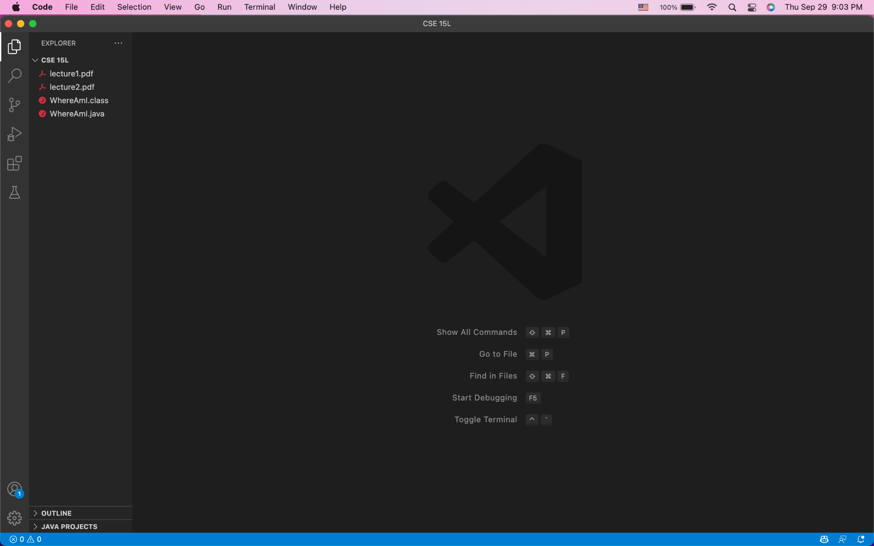

My first step is to install the Visual Studio Code on my computer. Then, I opened up my VS Code and this is the window that shows up.

Step 2: Remotely Connecting

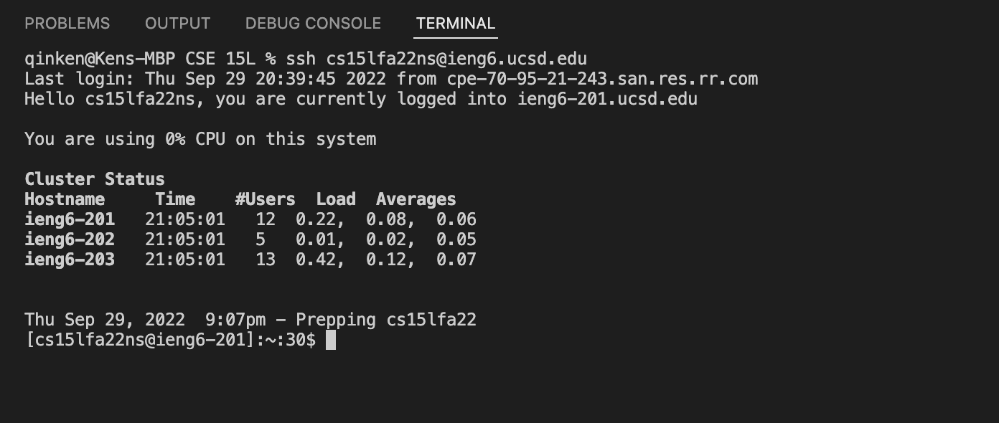

Then, I use the command “ssh [cs15lfa22ns@ieng6.ucsd.edu](mailto:cs15lfa22ns@ieng6.ucsd.edu)” to connect to the computer in the CSE basement (the server). Note that I was asked to enter a password before, and after I created a pair of SSH keys (in step 5), I was no longer asked to enter a password every time I connect to the server.

Step 3: Trying Some Commands

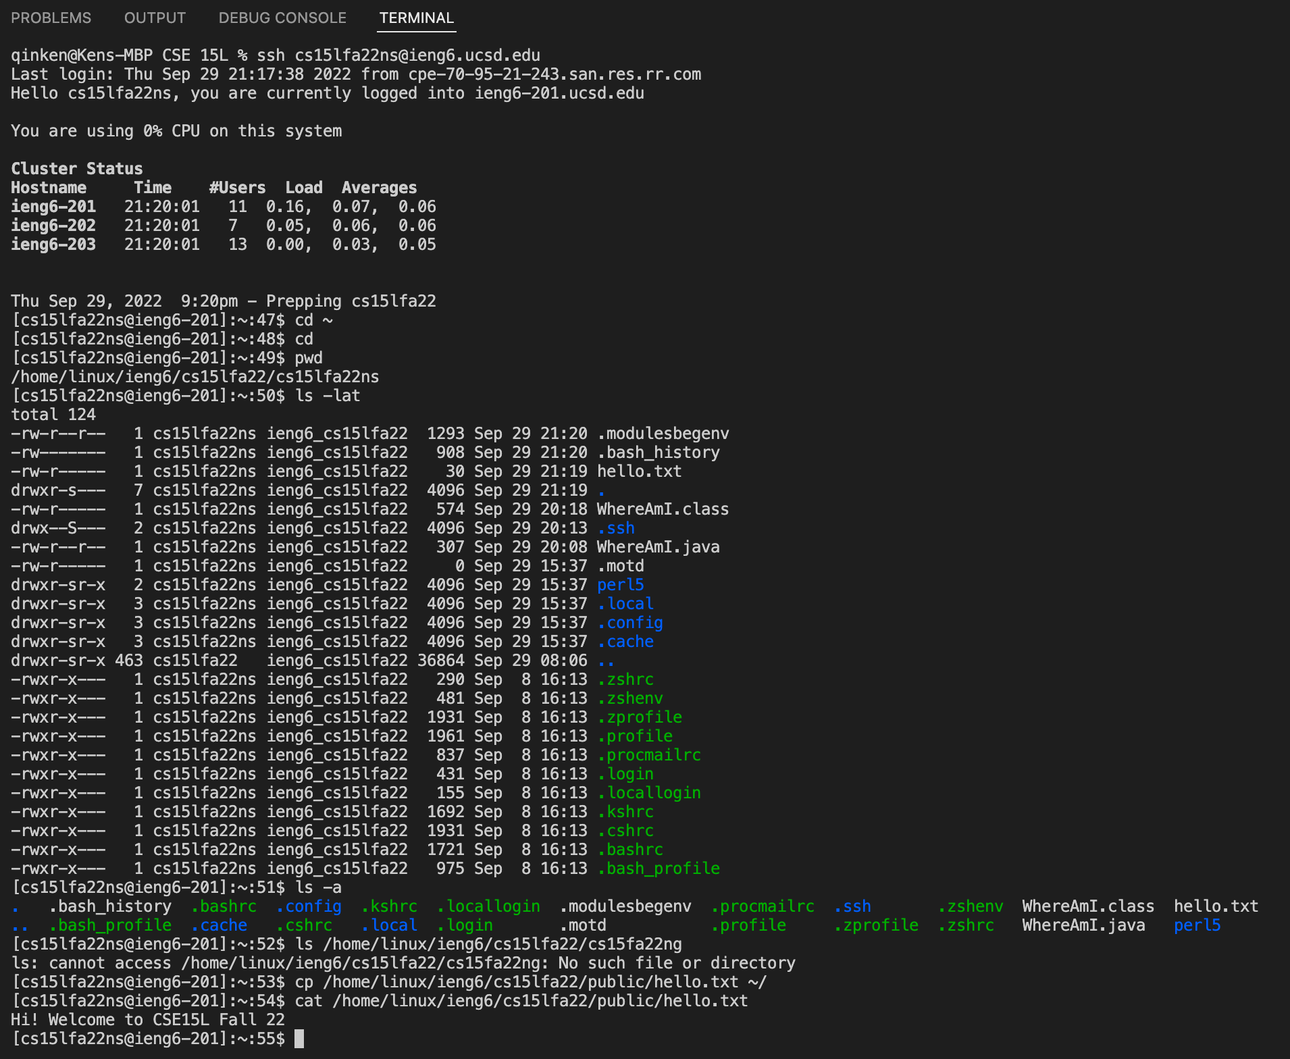

In this step, I tried running some useful commands provided in my remote terminal. Commands such as cd, pwd, ls, cat were all included. With a lot of them tell me about the information of the directory or the information of files on the remote computer.

Step 4: Moving Files with scp

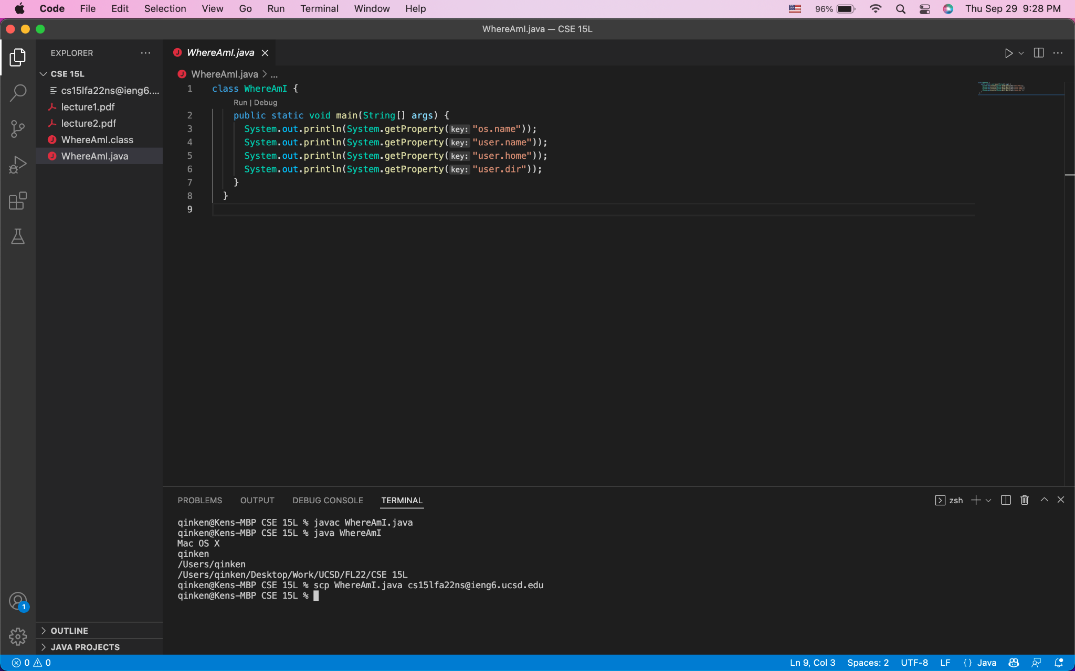

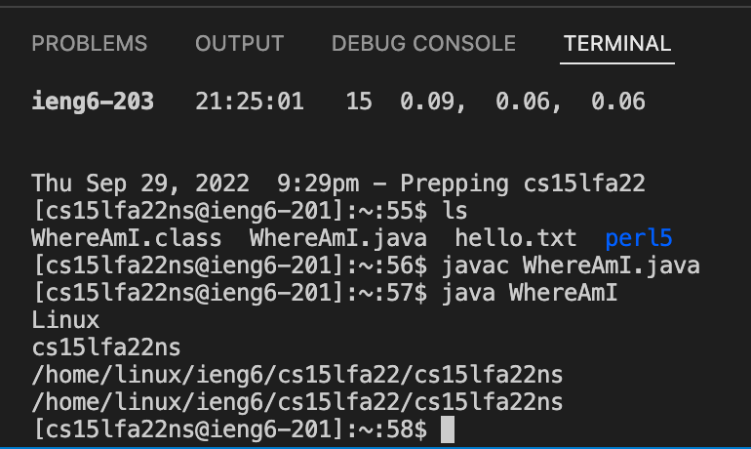In this step, I want to copy WhereAmI.java file to ssh. I first compile the program on my computer, and it prints out the information about the client using getProperty function, which shows my computer running on Mac OS. Then, I log in to ssh and use ls to see that the file was indeed copied to my directory. I run in ssh and it prints out the information about the server, which is the remote computer running on Linux.

Step 5: Setting an SSH Key

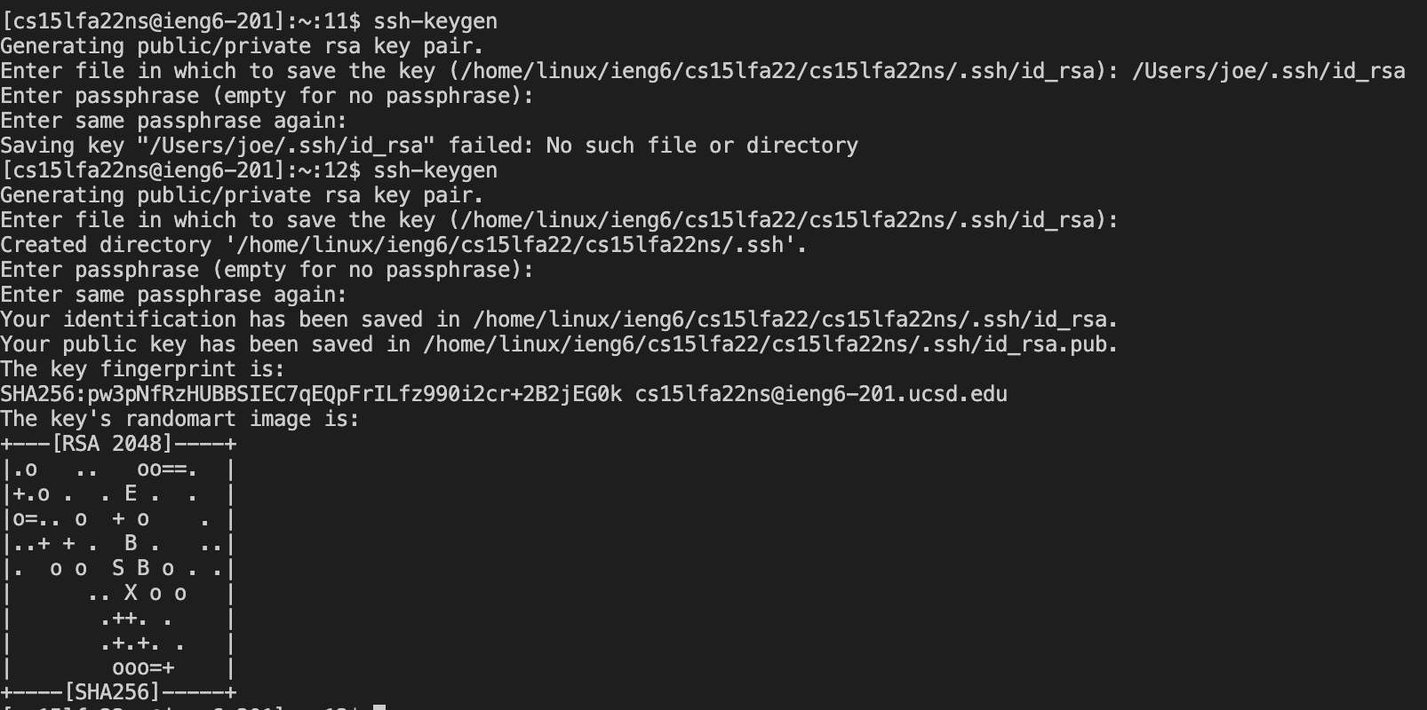

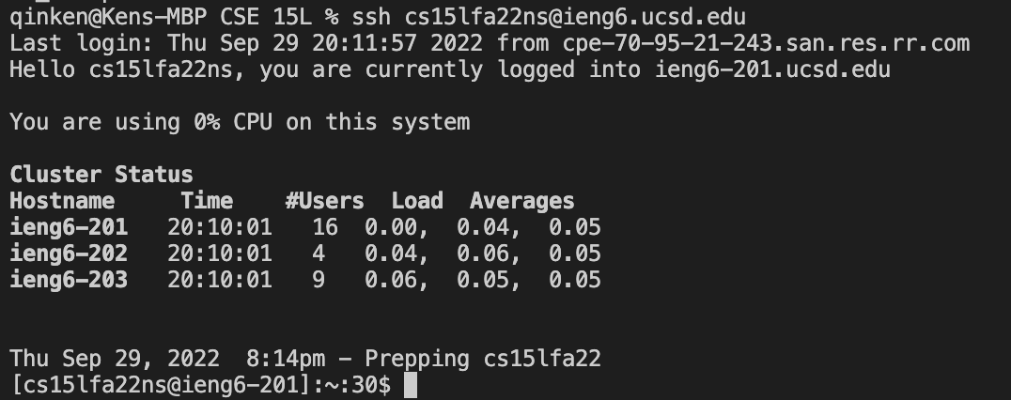

Now, I use the “ssh-keygen” command on my local terminal to create a pair of ssh keys. I then use the command “scp /Users/kenqin/.ssh/id_rsa.pub [cs15lfa22ns@ieng6.ucsd.edu](mailto:cs15lfa22ns@ieng6.ucsd.edu):~/.ssh/authorized_keys” to copy the public key onto the server, allowing me to connect remotely without having to enter my extremely long password every time.

Step 6: Optimizing Remote Running

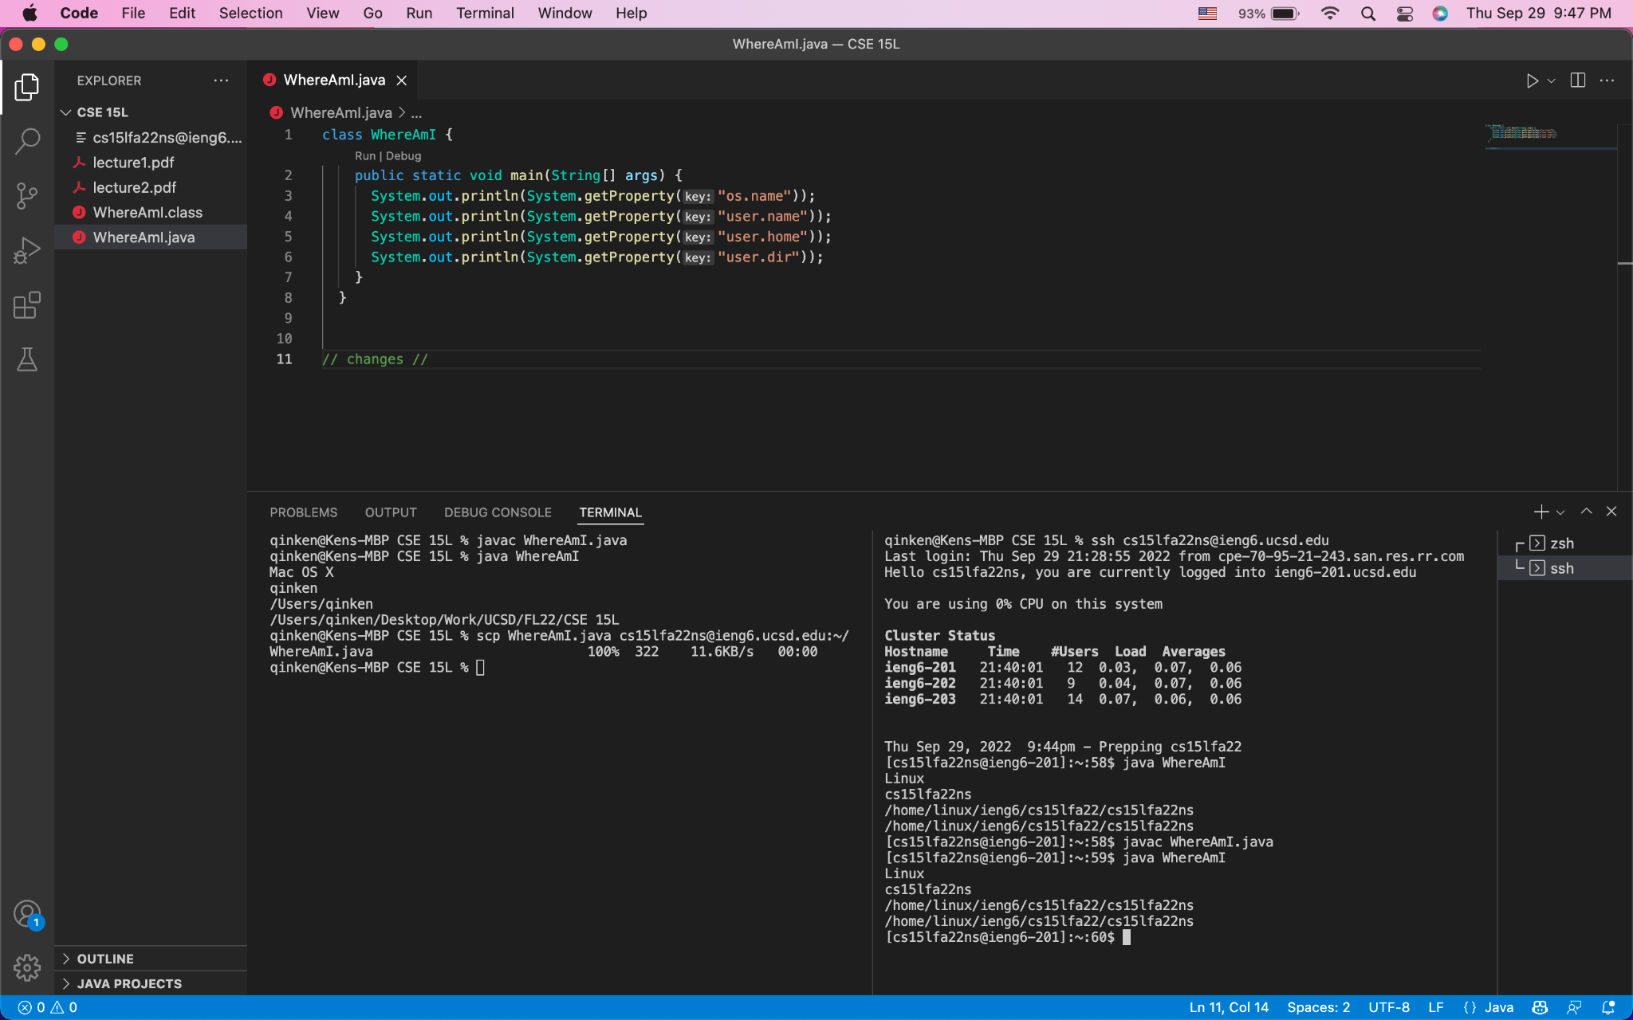

Lastly, I optimize my remote running with two split terminals. The left one is on the local while the right one is on the remote. I use copy-paste and up-arrow to retrieve previous commands, so reducing my overall keystrokes to very few. Successfully reducing the time spend on typing out all the commands.